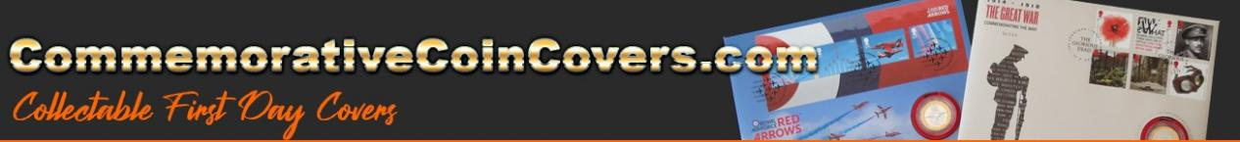

Year | Description | Coin Denomination
2003 | Anniversary of Queen’s coronation | £5.00
2004 | Entente Cordiale | £5.00
2005 | 60th Anniversary of the end of WWII | £2.00
2005 | World Heritage sites | 50p
2001 | Queen Victoria | £5.00
2002 | Queen’s Golden Jubilee | £5.00
2002 | Queen Mother, A Life Remembered | £5.00
2000 | Queen Mother 100th year | £5.00
2005 | The Written Word | 50p
2003 | Extreme Endeavours | £1.00
1997 | Queen’s Golden Wedding Anniversary | £5.00
1996 | Queen’s 70th birthday | £5.00
1998 | Notting Hill Carnival | 50p
1997 | Six Wives of Henry VIII | £1.00
1998 | Prince of Wales 50th birthday | £5.00
1995 | 50th anniversary of end of WWII | £2.00
1994 | 50th anniversary of D Day landings | 50p
2004 | Classic locomotives, 200 years of steam engines | £2.00
2003 | DNA discoveries | £2.00
2001 | Northern Ireland | £1.00
2005 | Exploring the Menai Straits | £1.00
2004 | A Fine Day Out on the Firth of Forth | £1.00
2000 | Millennium | £5.00
2004 | Spanning the Ocean | Medal
1995 | William Wyon | Medal
2003 | Posterity | Medal
2004 | Royal Horticultural Society | Medal
1999 | Berlin Airlift | Medal

